The Abacus API is implemented as an ASP.Net Web API that follows a standard RESTful architecture. The functionality exposes Abacus business logic resources and a set of stateless operations. The back-end code utilised by the API is the same as what is implemented by Abacus, AbacusWeb and AbacusField. The API may return messages in data formats such as XML and JSON per standard ASP.Net Web API functionality. Third party software or API integration services may directly call the Abacus API through code logic if desired. Abacus API resource examples include: Customer record, loan application, loan account, savings account, customer transaction, general ledger account, general ledger transaction, user, branch, etc.

To reduce software development tasks, integration tools such as API integration services or enterprise service buses may be utilised to accept message data to allow for manipulation before forwarding on data to the recipient destination either at the third party application or Abacus API. The below diagram gives an overview to the avenues data may traverse depending on the available functionality or option for configuration with the third party applications.

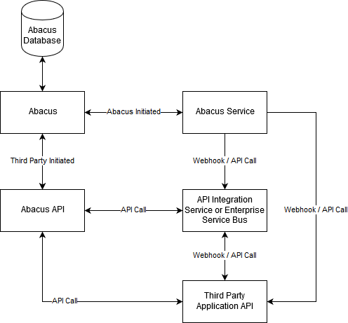

**Abacus Service**

For instances where the Abacus system is to initiate events, this is performed either via API polling from API integration services or via the use of triggers and webhooks from the Abacus Service. The Abacus Service is an executable Windows application that runs in the background in perpetuity on the client’s production server. The consistent nature of the service allows for configuration of periodic or real time process to be implemented. Such functionality includes the sending of SMS messages per events in the system, sending of periodic marketing or notice messages via email, forwarding of transaction or customer record details via webhook, or calling of third party applications via RESTful API calls.

**API Integration Services**

API integration services provide a simplified intermittent interface via which the Abacus API and third-party application APIs may be configured to communicate. Fern supports several tools that come configured with pre-existing API integrations for commercial software in areas such as accounting, ERP, CRM, and communication channels (e.g. Email, SMS, etc.). API integration services have the benefit of pre-existing configurations for some systems, and simplified web-based interfaces for transaction setup. Downsides of the approach however exist regarding potential limitations of messaging formats and complexity of transactions and intermittent data storage. It is common for the services to rely on transaction change polling rather than event driven actions. For more complicated implementations or messaging formats for ATM and POS integrations an enterprise service bus would be utilised.